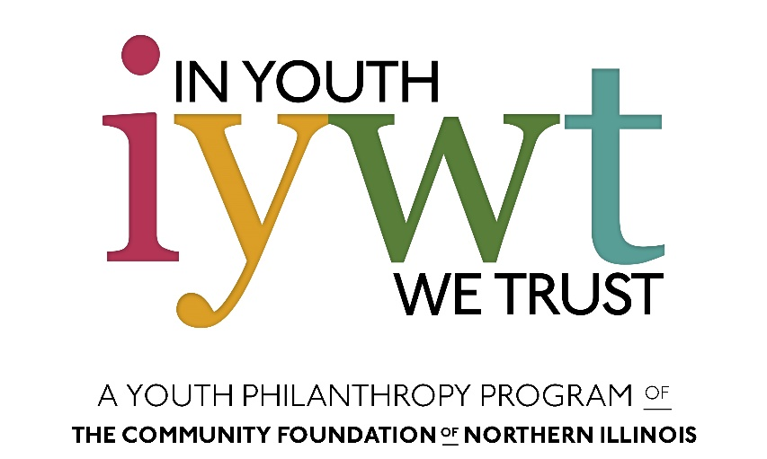

In Youth We Trust - Youth Grant Application 2022

INSTRUCTIONS:
Once you have completed this form, please email it to the IYWT Staff Liaison, Gabrielle Sims at gsims@cfnil.org with your budget (you must use the budget template provided on http://cfnil.org/grants/youth). You will get a confirmation that your application has been received, if you do not receive one, then contact Gabrielle Sims. The deadline is Tuesday, March 1st, 2022, at 5:00pm. No application will be accepted after the deadline.

For more detailed application guidelines, instruction, deadlines, and program information visit https://www.cfnil.org/grants/youth.

Questions?
Contact: Gabrielle Sims
Email: gsims@cfnil.org
Phone: 779-210-8209
Office hours: M-F, 8:30am-5:00pm

Organization Information

Name of Youth Club or Organization:
Youth group street address:
City:
State:
Zip Code:
County:
What is your group’s purpose and primary activities?
What is the name of your sponsoring or parent organization?
Sponsoring or parent organization street address:
City:
State:
Zip Code:
Type of organization:
EIN number of organization (Your adult contact should have this):
Primary Youth Contact
First and Last name:
Date of birth:
Street address:
City:
State:
Zip Code:
County:
Phone number:
Email:
Best time to reach you:
How many people under the age of 19 will be working on this project?
How many people older than 19 will be working on this project?
Primary Adult Contact
First and Last Name:
Street address (if different from parent organization):
City:
State:
Zip code:
County:
Work phone:
Cell phone:
Email:
Best time to reach you:
Project Information
Title of your project:
How much money are you requesting (max $3,500)?

Please give a short summary of your project:

Estimated project start date:
Estimated project end date:

Please give a detailed description of the project. Make sure to include any major tasks and how the group plans to accomplish them.

Where will the project take place?

How is this project inspired and driven by youth?

Are you working in collaboration with or receiving advice or assistance from any other organizations? If your answer is no, please leave this blank.

With whom are you collaborating, and what part (s) are your partner (s) playing in your project? If you are not collaborating with anyone, please leave this blank.

Do you need any special documents or permissions to complete or participate in our project? If yes, what do you need, and who will be responsible for obtaining it? If your answer is no, please leave this blank.

Is there anything else you would like us to know about your project?

Promotion
How will you promote this project? Think about who’s involved and should be recognized for their contributions, such as volunteers, other organizations, or funders and donors.

Community Need and Results
How will your project improve your community? What do you hope to achieve?

What are your intended results? What method or tool do you plan to use to measure your results?

How many people will benefit from the project?

How did you determine this number?

Describe the population or groups who will benefit from your project. Think about the number of people who will benefit and their genders, ages, and other demographic information.

What county will your project primarily serve?

How will the members of your group benefit from implementing this project?

Finances
Please email your budget along with your application to gsims@cfnil.org. Your proposal budget MUST use CFNIL’s Budget Template for In Youth We Trust found on cfnil.org/grants/youth

Budget Narrative: Explain how each expense relates to the proposal’s goals:

Additional Info
How did you hear about IYWT?

Applicant Agreement
By signing below, I agree to the following terms and conditions of the Community Foundation of Northern Illinois (hereafter “FOUNDATION”) on behalf of my organization (hereafter “GRANTEE”). Additionally, I certify that I am authorized to agree to these terms and conditions.
- To use the funds only for the designated purpose as described in the grant application and subsequent grant notification letter and not for any other purpose without the FOUNDATION’s prior written approval.
- To not expend any grant funds for any political or lobbying activity or for any purpose other than one specified in section 170(c)(2)(b) of the Code.
- To notify the FOUNDATION immediately of any change in (a) GRANTEE’S legal or tax status, (b) GRANTEE’S executive or key staff responsible for achieving the grant purposes, (c) GRANTEE’S ability to expend the grant for the intended purpose, and (d) any expenditure from this grant for any purpose other than those for which the grant was intended.
- To maintain books and records adequate to demonstrate that it maintained the grant funds in a separate fund dedicated to the purpose for which the grant is made, and to maintain records of expenditures adequate to identify the purposes for which, and manner in which, grant funds have been expended.
- To give the FOUNDATION reasonable access to the grantee’s files and records for the purpose of making such financial audits, verifications, and investigations as it deems necessary concerning the grant, and to maintain such files and records for a period of at least four years after completion or termination of the project. 6. To return to the FOUNDATION any unexpended funds or any portion of the grant that is not used for the purposes specified herein.
- To allow the FOUNDATION to review and approve the content of any proposed publicity concerning this grant prior to its release and to recognize the FOUNDATION in all publicity materials related to the funded project or program, as specified in the Grantee Communication Guidelines, which will be included in the grant notification letter.
- To allow the FOUNDATION to include information about this grant in the FOUNDATION’s periodic public reports, newsletter, news releases, social media postings, and on the FOUNDATION’s website. This includes the amount and purpose of the grant, any photographs you have provided, your logo or trademark, and other information and materials about your organization and its activities.
- To submit a written report summarizing the project promptly following the end of the period during which you are to use all grant funds and to submit any interim reports the FOUNDATION may require. Your reports should describe your progress in achieving the purposes of the grant and include a detailed accounting of the use and expenditure of grant funds.
The FOUNDATION reserves the right to discontinue, modify or withhold any payments under this grant award or to require a total or partial refund of any grant funds if, in the FOUNDATION’s sole discretion, such action is necessary: (a) because you have not fully complied with the terms and conditions of this grant; (b) to protect the purpose and objectives of the grant or any other charitable activities of the FOUNDATION; or (c) to comply with the requirements of any law or regulation applicable to you, the FOUNDATION, or this grant.
Please check the box to indicate that you have read and understand these terms and conditions.
- I understand and accept these terms and conditions
Name (Printed): ____________________________________________

Signature: _______________________________________________ Date: ___________________

